

**Anterior Cruciate Ligament Reconstruction**

**- GGC Guidelines for Rehabilitation -**

**Updated March 2019**



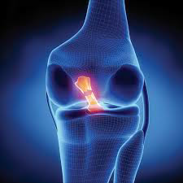

**Contents**

Introduction 1

Contacts 2

Phase 1 3

Phase 2 5

Phase 3 6

Phase 4 7

Appendices

Lower Extremity Functional Scale (LEFS) 8

ACL – Return to Sport after Injury (ACLRSI) 10

Hop Tests 12

Y-Balance Test 13

Measuring Strength 14

Video Links 15

Return to Running 17

Record Sheet (for monitoring and audit) 18

References 19

# Introduction

Anterior Cruciate Ligament reconstruction surgery is carried out in various sites across NHSGGC as a day surgery procedure with patients discharged following assessment by the orthopaedic inpatient physiotherapists.

These guidelines are for outpatient rehabilitation to commence within 3-6 days following surgery and may continue for up to 6-12 months following surgery depending on patient progress and individual goals.

Treatment should be based on **individual needs** and **appropriate clinical decision making** regarding the progression of the patient’s post-operative course. The actual post-surgical physiotherapy management must be based on the physical examination, individual progress and the presence of complications. **Please review the patient’s operation note to clarify any specific instructions.** Some patients will not meet the early targets due to pain/swelling/other underlying conditions in the knee or other extenuating circumstances.

Orthopaedic outpatient clinic review is carried out by local surgical protocol and individual clinical need.

January 2019

Katie Black

Kirsty Forsythe

Norma Goodfellow

Martijn Kaan

Alistair MacFie

Christine O’Donnell

Rosemarie Quinn

Craig Ruddy

Donald Todd

**Contacts**

**In case of any clinical concerns please contact:**

* Norma Goodfellow / Rosemarie Quinn (GRI)
* Alistair MacFie / Christine O’Donnell (VACH)
* Martijn Kaan / Stephen Bain (WACH/GGH)
* Katie Black (RAH)
* Bruce Coyle (Inverclyde)

**LOCAL CLASSES and CONTACTS**

**West Glasgow ACH – Yorkhill (Catriona Dunwoodie)**

Monday 1500 - 1630

Thursday 0800 - 1000

**Gartnavel General Hospital (Becky Dunphy)**

Tuesday 0830 - 1030

Friday 0830 - 1030

**Glasgow Royal Infirmary (Rosemarie Quinn and Jayne Ford Anderson)**

Monday 1300 - 1400

Thursday 1300 - 1400

**Stobhill Hospital (Fergal Lally)**

Monday 1600 - 1730

**Royal Alexandra Hospital (Katie Black)**

Thursday 1700 - 1800

**Inverclyde Royal Hospital (Hassine Hamraras)**

Monday 1045 - 1145

Wednesday 1045 - 1145

Please contact one of the above in case of changes to time, location or staff.

Phase 1

**Day 1 onwards, see patient information booklet given on discharge**

**NB. Progression of the exercises will be dictated by the patient’s level of pain and swelling.**

* Continue with ice/compression/elevation until effusion resolves.
* Continue ROM exercises until full knee extension is achievable with ease.
* Continue using walking aid(s) until full extension and quadriceps control on the operated leg is achieved and there is no evidence of a limp.
* The wound dressing can be removed at ~ 7-10 days post surgery.
* If you have any concerns regarding the wound/suspected infection request that the patient contacts the orthopaedic department/A&E.

|  |  |
| --- | --- |
| **Goals of Phase** | Monitor wound  Commence ROM and strengthening exercises  Achieve terminal extension  Gait re-education  Proprioceptive exercises  Set patient specific Goals |
| **Includes** | Knee ROM  Prone Stretch  Long sitting Calf Stretch  **Quadriceps**   * Static quads in long sitting * Knee bracing in standing * Straight Leg Raise   **Hip Strength**  Abduction in supine, progress to side lying  Hip Extensors - Prone lying, passive knee flexion to 900, extend hip (use assistance of other leg when initiating bending and straightening of the knee) |
| **Progress to**  **Progress to** | **Increase quads strength**  e.g. terminal extension with theraband  mini squats 0-500  **Calf strength** – bilateral heel raises  **Calf Flexibility -** Standing calf stretch  **Proprioception**:  Weight transference:  1) Forward/lateral in standing  2) Unilateral stand as able with full knee extension  3) Single leg stance  **CV:** static bike |
| **Aims & Outcome Measures for progression to phase 2** | Terminal extension achieved  Normal Gait pattern unaided  No worsening effusion  Baseline LEFS (Lower Extremity Functional Score) at 2 weeks |

Phase 2

**4-12 weeks approx**

**Treatment should be based on individual needs and appropriate clinical decision making regarding the progression of the patient’s post-operative course.**

|  |  |
| --- | --- |
| **Goals of Phase** | Progress strength and conditioning  Commence return to running programme  Commence basic agility |
| **Includes** | **Develop Full ROM/Flexibility**   * Calf * Quads * Hamstring * Hip Flexors * Ab/adductors   **Strength**  Progress from bilateral → unilateral  e.g. calf raise, squat, step up, posterior chain/bridge variations, lunge  **Proprioception**  **CV**  Cycling, cross trainer, pool (exercises, gentle front crawl, back crawl – no breaststroke until 3 months), walk/jog programme (see appendix) |
| **Progress to** | **Return to Running Criteria – See Appendix**  **Agility (no pivoting) – see appendix**  **Early Plyometrics – e.g. skipping / landing drills**  For examples – see Appendices |
| **Aims & Outcome Measures for progression to phase 3** | * Full ROM flexion & Extension * Working through Return to running programme pain free and controlled effusion * Single Hop test 80% Limb Symmetry Index (LSI) * Strength 80% LSI (Single leg sit to stand / leg press) * Single Leg Bridge 80% LSI |
| **Measures of Improvement** | Complete:   * Y-Balance * LEFS 6 weeks and 12 weeks |

Phase 3

**3-6 months approx - Dynamic Training**

**Treatment should be based on individual needs and appropriate clinical decision making regarding the progression of the patient’s post-operative course.**

|  |  |
| --- | --- |
| **Goals of Phase** | Progress strength & conditioning  Progress Agility  Continue Running Programme  Jumping drills |
| **Includes** | **Ongoing strength training**  **Double leg/multi-directional jumps**  **Hopping**  **Progress CV/Endurance training**  **Progress agility – can gradually introduce pivoting**  For examples – see Appendices |
| **Progress to** | **Prepare for sports specific training** |
| **Aims & Outcome Measures for progression to Phase 4** | * Pain & effusion free continuous running relative to patient goals * Hop test battery 90% LSI * Strength 90% LSI (Single leg Sit To Stand / leg press) * Single Leg Bridge 90% LSI |
| **Measures of Improvement** | Complete:   * Y-Balance * LEFS 20 weeks |

Phase 4

**>6 months approx - Sports specific Training**

**Treatment should be based on individual needs and appropriate clinical decision making regarding the progression of the patient’s post-operative course.**

|  |  |
| --- | --- |
| **Goals** | Introduce sports specific movements in a controlled environment |
| **Includes** | **Progress to advanced agility / sports specific drills**  **Ongoing strength and CV**  For examples – see Appendices |
| **Aims** | Hop test 90-100% LSI  Strength 90-100% LSI (Single leg STS / leg press)  Single leg bridge 90-100% LSI  ACL-RSI if indicated  **SET GOALS ACHIEVED** |

# Appendices

## Lower Extremity Functional Scale

[**Physiopedia Link**](https://www.physio-pedia.com/Lower_Extremity_Functional_Scale_(LEFS))

***Patient Label***

Date: June 19, 2019

We are interested in knowing whether you are having any difficulty at all with the activities listed below *because of your lower limb problem* for which you are currently seeking attention. Please provide an answer for *each* activity.

|  |  |  |  |  |  |
| --- | --- | --- | --- | --- | --- |
| **Today, *do you* or *would you* have any difficulty at all with:** | **Extreme difficulty or unable to perform activity** | **Quite a bit of**  **difficulty** | **Moderate difficulty** | **A little bit of**  **difficulty** | **No**  **difficulty** |
| 1. Any of your usual work, housework or school activities. | 0 | 1 | 2 | 3 | 4 |
| 2. Your usual hobbies, recreational or sporting activities. | 0 | 1 | 2 | 3 | 4 |
| 3. Getting into or out of the bath. | 0 | 1 | 2 | 3 | 4 |
| 4. Walking between rooms. | 0 | 1 | 2 | 3 | 4 |
| 5. Putting on your shoes or socks. | 0 | 1 | 2 | 3 | 4 |
| 6. Squatting. | 0 | 1 | 2 | 3 | 4 |
| 7. Lifting an object, like a bag of groceries from the floor. | 0 | 1 | 2 | 3 | 4 |
| 8. Performing light activities around your home. | 0 | 1 | 2 | 3 | 4 |
| 9. Performing heavy activities around your home. | 0 | 1 | 2 | 3 | 4 |
| 10. Getting into or out of a car. | 0 | 1 | 2 | 3 | 4 |
| 11. Walking 2 blocks. | 0 | 1 | 2 | 3 | 4 |
| 12. Walking a mile. | 0 | 1 | 2 | 3 | 4 |
| 13. Going up or down 10 stairs (about1 flight of stairs). | 0 | 1 | 2 | 3 | 4 |
| 14. Standing for 1 hour. | 0 | 1 | 2 | 3 | 4 |
| 15. Sitting for 1 hour. | 0 | 1 | 2 | 3 | 4 |
| 16. Running on even ground. | 0 | 1 | 2 | 3 | 4 |
| 17. Running on uneven ground. | 0 | 1 | 2 | 3 | 4 |
| 18. Making sharp turns while running fast. | 0 | 1 | 2 | 3 | 4 |
| 19. Hopping. | 0 | 1 | 2 | 3 | 4 |
| 20. Rolling over in bed. | 0 | 1 | 2 | 3 | 4 |
| **Column Totals:** |  |  |  |  |  |

Source: Binkley JM, Stratford PW, Lott SA, Riddle DL. The Lower Extremity Functional Scale (LEFS): scale development, measurement properties, and clinical application. North American Orthopaedic Rehabilitation Research Network. *Phys Ther*. 1999 Apr;79(4):371-83.

The Lower Extremity Functional Scale (LEFS) is a questionnaire containing 20 questions about a person’s ability to perform everyday tasks. The LEFS can be used by clinicians as a measure of patients' initial function, ongoing progress and outcome, as well as to set functional goals.

The LEFS can be used to evaluate the functional impairment of a patient with a disorder of one or both lower extremities. It can be used to monitor the patient over time and to evaluate the effectiveness of an intervention.

**Scoring instructions**

The columns on the scale are summed to get a total score. The maximum score is 80.

**Interpretation of scores**

* The lower the score the greater the disability.

## ACLRSI - Anterior Cruciate Ligament – Return to Sport after Injury

**Instructions:**

Rate the following questions on a scale of 0-10, with 0 being extremely and 10 not at all.

|  |  |  |  |  |
| --- | --- | --- | --- | --- |
| **1. Are you nervous about playing your sport?** | | |  |  |
| Not at all 0 1 2 3 4 5 6 7 8 9 | | | 10 | Extremely |
| **2. Do you find it frustrating to have to consider your knee with respect to your sport?** | | |  |  |
| Not at all 0 1 2 3 4 5 6 7 | 8 | 9 | 10 | Extremely |
| **3. Do you feel relaxed about playing your sport?** |  |  |  |  |
| Not at all 0 1 2 3 4 5 6 7 | 8 | 9 | 10 | Extremely |
| **4. Are you fearful of re-injuring your knee by playing your sport?** |  |  |  |  |
| Not at all 0 1 2 3 4 5 6 7 | 8 | 9 | 10 | Extremely |
| **5. Are you afraid of accidentally injuring your knee by playing sport?** |  |  |  |  |
| Not at all 0 1 2 3 4 5 6 7 | 8 | 9 | 10 | Extremely |
| **6. Are you confident that your knee will not give way by playing sport?** |  |  |  |  |
| Not at all 0 1 2 3 4 5 6 7 8 9 | | | 10 | Extremely |
| **7. Are you confident that you could play your sport without concern for your knee?** | | |  |  |

Not at all 0 1 2 3 4 5 6 7 8 9 10 Extremely



1

|  |  |
| --- | --- |
| **8. Are you confident about your knee holding up under pressure?** |  |
| Not at all 0 1 2 3 4 5 6 7 8 9 10 | Extremely |
| **9. Are you confident that you can perform at your previous level of sport participation?** |  |
| Not at all 0 1 2 3 4 5 6 7 8 9 10 | Extremely |
| **10. Are you confident about your ability to perform well at your sport?** |  |
| Not at all 0 1 2 3 4 5 6 7 8 9 10 | Extremely |
| **11. Do you think you are likely to re-injure your knee by participating in your sport?** |  |

Not at all 0 1 2 3 4 5 6 7 8 9 10 Extremely



**12. Do thoughts of having to go through surgery and rehabilitation again prevent you from playing your sport?**

Not at all 0 1 2 3 4 5 6 7 8 9 10 Extremely



**Score ACL-RSI (Total x 100) / 120 = ____ %**

## Hop Tests

Video Link: <https://www.youtube.com/watch?v=OejqiPbxs4g>

**SINGLE HOP (A):**

The test is a single ‘big’ hop covering the maximum possible distance and landing on the same leg. It is performed 3 times on each side with the average distance for each leg obtained. The percentage distance between the 2 sides is then calculated. Aim for 85% of distance covered by non-operated leg.

**TRIPLE HOP (B):**

The triple hop for distance is performed with the patient standing on 1 leg and performing 3 consecutive hops as far as possible.

**CROSSOVER HOP (C):**

The crossover hop for distance is performed with the patient standing on one leg and performing 3 consecutive hops as far as possible while crossing a centre ling with each consecutive hop.

[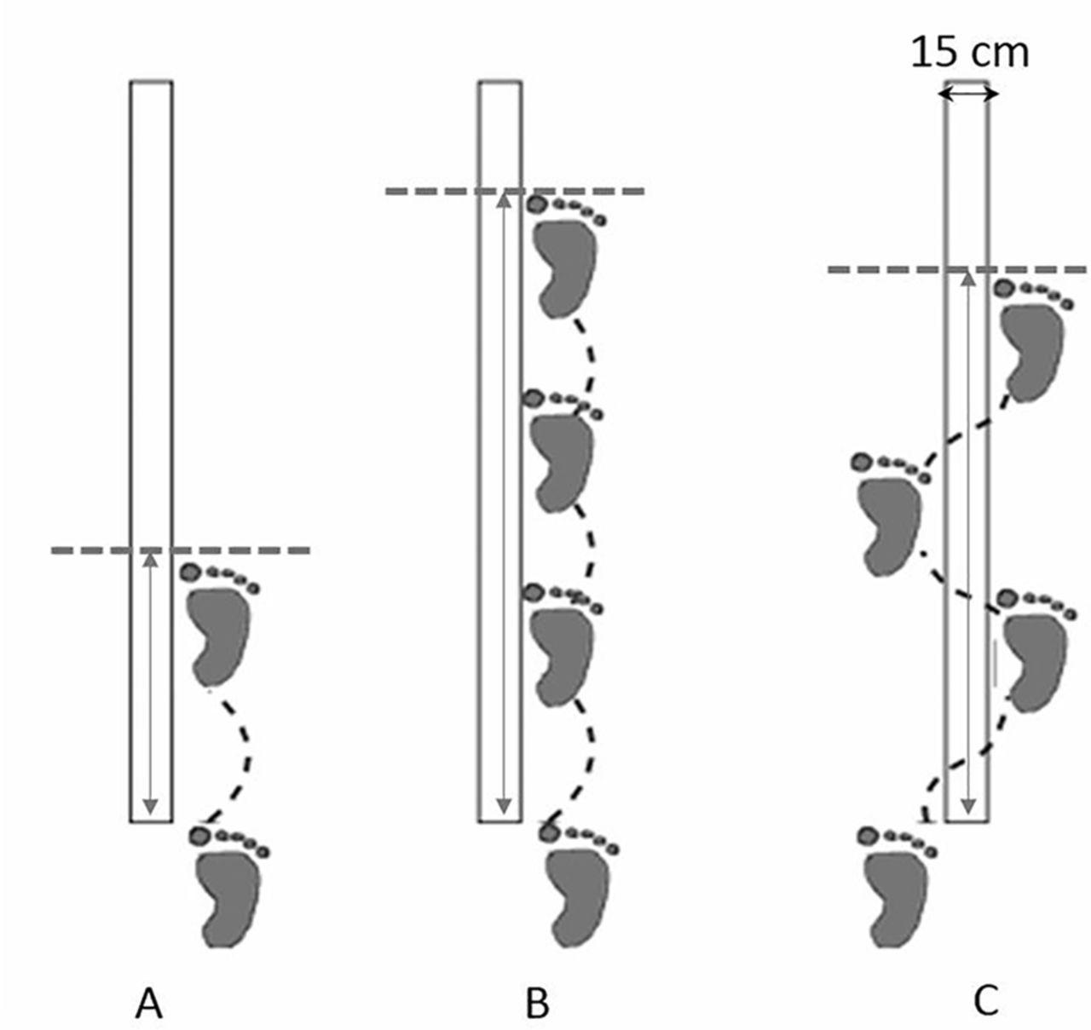](http://www.google.co.uk/url?sa=i&rct=j&q=&esrc=s&source=images&cd=&ved=0ahUKEwjiwavIu5_WAhUKJcAKHWe2BlIQjRwIBw&url=http://bmjopen.bmj.com/content/7/6/e015087&psig=AFQjCNHs4Tf2Ot6WUEUnk6f)

## 

## Y-Balance Test

<https://www.scienceforsport.com/y-balance-test/>

Video Link: <https://www.youtube.com/watch?v=kUBpKXAgo2s>

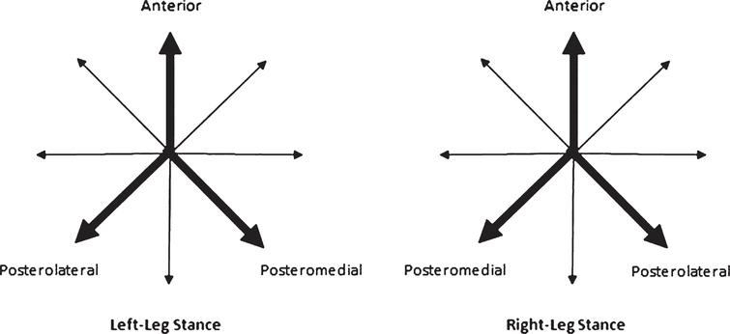

Scoring Chart:

|  |  |  |  |  |
| --- | --- | --- | --- | --- |
|  | Right | Left | Diff | Initial/sign |
| Anterior |  |  |  |  |
| Postero-medial |  |  |  |  |
| Postero-lateral |  |  |  |  |
| TOTAL |  |  |  |  |

Total Difference should be less than 4cm if planning on return to Sport/Advanced Functional task

**Measuring Strength**

**Leg Press/Sit to Stand**

Test either Leg Press (if machine is available) or single leg sit to stand

Leg Press

Measuring 1RM in post operative patients/rehabilitation may not be appropriate; either 5RM/10RM may be more suitable.

LSI can be calculated using these parameters.

If leg Press is unavailable then a max rep single leg sit to stand can be used, this is demonstrated in the below video:

Mick Hughes <https://www.youtube.com/watch?v=-VQ9DtPRrBU>

**Measuring Strength – Single Leg Bridge**

Patient in Supine bridge position, knees at 90˚. Ask patient to lift one foot from the floor and proceed to bridge 20 repetitions

or until fatigue or unable to complete a full repetition.

Repeat on opposite leg.

Use the numbers for each leg to calculate LSI.

## Pure Physio <https://youtu.be/A_irxl-8_rQ>

## Calculating LSI/RSI

**Calculation of Limb Symmetry Index (LSI)**

LSI (%) = Injured Limb Score ÷ uninjured limb score x 100

**Calculation of Relative Strength Index (RSI)**

RSI (%) = weight pushed (Kg) ÷ bodyweight (Kg) x100

**Video Links - Exercise Ideas**

**These videos are included to give you some ideas, ensure you have assessed the patient’s readiness to progress/perform the exercise by referring to the guideline.**

**Phase 1**

ACL Reconstruction Rehab- Matthew Boes Video 1&2

<https://youtu.be/7TAslg8p2Vo?list=PLMnHlHoq4yFSjXGYFg6Aw0LqTvgIaYs5f>

Terminal knee extension - <https://www.youtube.com/watch?v=cU1rJjacMFE>

**Phase 2**

ACL Reconstruction Rehab- Matthew Boes

Video 3 <https://www.youtube.com/watch?v=M9thyTdrYxw>

Video 4 <https://www.youtube.com/watch?v=1zv-tPGjXqY>

Hamstring Strength

“Tantrum” Hamstring – Mick Hughes <https://www.youtube.com/watch?v=etp6-G0SJc4>

Arabesque for Hamstring

<https://www.youtube.com/watch?v=ee6szWZTyuM>

Glider hamstring exercise (from Aspetar Hamstring protocol) <https://www.youtube.com/watch?v=UU8pRuYL4b4&index=28&list=PLkeoBd4A272PvOD-KSdr_uELkF6kvvL8G>

(RDL) Single leg Romanian dead lift <https://www.youtube.com/watch?v=WAMBVWe65Qo>

Bridging progression ideas:

Bridge Progression - Christopher Johnson <https://www.youtube.com/watch?v=WpQFJBfWIlo>

Single leg bridge (from Aspetar Hamstring protocol) <https://www.youtube.com/watch?v=ada1X4jipe0&index=29&list=PLkeoBd4A272PvOD-KSdr_uELkF6kvvL8G>

Single Leg hamstring bridge - chair <https://www.youtube.com/watch?v=vfFUqJ3sn88>

Bridge on stability Ball with progressions <https://www.youtube.com/watch?v=czf-1snzG2c>

Single Leg gymball Hamstring Bridge <https://www.youtube.com/watch?v=jS2Lf59urv4>

## RETURN TO RUNNING – Mick Hughes <https://www.youtube.com/watch?v=MnBVw3in8B4>

## Examples of early drills <https://www.youtube.com/watch?v=HvH5WZk0f90>

Landing - Mick Hughes <https://www.youtube.com/watch?v=XI_VQQaPblo>

## Early Plyometrics - Fusion Sport <https://www.youtube.com/watch?v=yI2PPMsvPNg&t=128s>

Ladder drills with progression – Redefining Strength (phase 2/3) <https://www.youtube.com/watch?v=67XP-AekUoA>

**Phase 3**

Mick Hughes Plyometric sequence 1 <https://www.youtube.com/watch?v=ek1uudCX97U>

Plyometric sequence 2 <https://www.youtube.com/watch?v=u-bx1X6tjus>

Cone drills - Redefining Strength <https://www.youtube.com/watch?v=a2sCgSIOFIg>

## Mini Hurdle Drills – Nick Parasiliti <https://www.youtube.com/watch?v=aQwKvO4yCG4>

King Sports <https://www.youtube.com/watch?v=aQwKvO4yCG4>

Reaction drills cones <https://www.youtube.com/watch?v=OejqiPbxs4g>

Nordic hamstrings - (from Aspetar Hamstring Protocol) <https://www.youtube.com/watch?v=ygdv2gZiT6Y&index=32&list=PLkeoBd4A272PvOD-KSdr_uELkF6kvvL8G>

ACL Reconstruction Rehab- Matthew Boes Video 6

<https://www.youtube.com/watch?v=ZWu9MSC6WMw&index=7&list=PL8SDFq4IlgdWCRrMIpYfNy7D0HLEQoVZ6&t=0s>

**Phase 4 – sports specific**

Football Decision making drill Football (from 40sec) <https://www.youtube.com/watch?v=kbZ4YAp0ucs>

Racquet / footwork drills <https://www.youtube.com/watch?v=-UubC-SIQz4>

Rugby speed / agility /stepping drills <https://www.youtube.com/watch?v=2jJrZd3ZcYs>

Jump exercises for basketball <https://www.youtube.com/watch?v=bjzgqbQp_k0>

## RETURN TO RUNNING (guideline)

## RETURN TO RUNNING CRITERIA – Mick Hughes <https://www.youtube.com/watch?v=MnBVw3in8B4>

**SIGNS OF TOO RAPID PROGRESSION:**

* **Increased pain**
* **Increased swelling**
* **Decreased range of movement**

|  |  |  |
| --- | --- | --- |
| **Walk** | **Run** | **Reps** |
| 4min 30secs | 30secs | 6 |
| 4min | 1min | 6 |
| 3min 30secs | 1min 30secs | 6 |
| 3min | 2min | 6 |
| 2min 30secs | 2min 30secs | 6 |
| 2min | 3min | 6 |
| 1min 30secs | 3min 30secs | 6 |
| 1min | 4min | 6 |
| 30secs | 4min 30secs | 6 |
| 0 | 30 minutes | 1 |

**↓**

**PROGRESS SPEED/DISTANCE AS ABLE**

**↓**

**‘SINGLE HOP TEST FOR DISTANCE TEST’**

**↓**

**‘START-STOP DRILLS’ – NO PIVOTING/TWISTING**

**LADDER DRILLS, DOUBLE LEG JUMPS, TUCK JUMPS, HOPPING ON THE SPOT, STRAIGHT LINE HOPPING**

## 

|  |  |  |  |  |  |  |  |  |  |  |  |  |  |  |  |  |
| --- | --- | --- | --- | --- | --- | --- | --- | --- | --- | --- | --- | --- | --- | --- | --- | --- |
|  | Post Op | | Week 2 | | Week 6 | | | Week 12 | | | Week 20 | | | Discharge | | |
|  | __/__/____  Sign: | | __/__/____  Sign: | | __/__/____  Sign: | | | __/__/____  Sign: | | | __/__/____  Sign: | | | __/__/____  Sign: | | |
|  | Injured | Uninjured | Injured | Uninjured | Injured | | Uninjured | Injured | | Uninjured | Injured | | Uninjured | Injured | | Uninjured |
| VAS | /10 |  | /10 |  | /10 | |  | /10 | |  | /10 | |  | /10 | |  |
| LEFS |  |  |  |  |  | |  |  | |  |  | |  |  | |  |
| Leg Press |  | |  | | LSI: |  | | LSI: |  | | LSI: |  | | LSI: |  | |
| Hop |  |  |  |  |  | |  | LSI: |  | | LSI: |  | | LSI: |  | |
| Triple Hop |  | |  | |  | | | LSI: |  | | LSI: |  | | LSI: |  | |
| Crossover Hop |  | |  | |  | | | LSI: |  | | LSI: |  | | LSI: |  | |
| Single leg bridge |  | |  | |  | | | LSI: |  | | LSI: |  | | LSI: |  | |
| Y-Balance |  | |  | |  | | | Diff |  | | Diff |  | | Diff |  | |
| ACL-RSI |  |  |  |  |  | |  |  | |  |  | | |  | | |

## References

Patient Label

1. Atkinson, H. D., Laver, J. M., & Sharp, E. (2010). (Vi) Physiotherapy and rehabilitation following soft-tissue surgery of the knee. *Orthopaedics and Trauma, 24*(2), 129-138.

2. Dingenen, B., & Gokeler, A. (2017). Optimization of the return-to-sport paradigm after anterior cruciate ligament reconstruction: A critical step back to move forward. *Sports Medicine,* 1-14.

3. Escamilla, R. F., MacLeod, T. D., Wilk, K. E., Paulos, L., & Andrews, J. R. (2012). Cruciate ligament loading during common knee rehabilitation exercises. *Proceedings of the Institution of Mechanical Engineers, Part H: Journal of Engineering in Medicine, 226*(9), 670-680.

4. Glen Sather Sports Medicine Clinic. (2017). ***GSSMC anterior cruciate ligament (ACL) protocol****.*, 2018, from <https://cloudfront.ualberta.ca/-/media/glensatherclinic/forms/acl-gssmc-protocol-20170329.pdf>

5. Heijne, A., & Werner, S. (2007). *Knee Surgery, Sports Traumatology, Arthroscopy, 15*(4), 402-414.

Herrington, L., Myer, G., & Horsley, I. (2013). Task based rehabilitation protocol for elite athletes following anterior cruciate ligament reconstruction: A clinical commentary. *Physical Therapy in Sport, 14*(4), 188-198.

6. Myer, G. D., Paterno, M. V., Ford, K. R., Quatman, C. E., & Hewett, T. E. (2006). Rehabilitation after anterior cruciate ligament reconstruction: Criteria-based progression through the return-to-sport phase. *Journal of Orthopaedic & Sports Physical Therapy, 36*(6), 385-402.

7. Myklebust, G., & Bahr, R. (2005). Return to play guidelines after anterior cruciate ligament surgery. *British Journal of Sports Medicine, 39*(3), 127-131.

8. Ebben, W.P. (2007). Practical guidelines for plyometric intensity. *NSCAs Performance training journal, 6(5)*.

9. Rambaud, A. J. M., Semay, B., Samozino, P., Morin, J. B., Testa, R., Philippot, R., et al. (2017). Criteria for return to sport after anterior cruciate ligament reconstruction with lower reinjury risk (CR'STAL study): Protocol for a prospective observational study in France. *BMJ Open, 7*(6), e015087-2016-015087.

10. Risberg, M. A., & Holm, I. (2009). The long-term effect of 2 postoperative rehabilitation programs after anterior cruciate ligament reconstruction: A randomized controlled clinical trial with 2 years of follow-up. *The American Journal of Sports Medicine, 37*(10), 1958-1966.

11. Shaw, T., Williams, M. T., & Chipchase, L. S. (2005). Do early quadriceps exercises affect the outcome of ACL reconstruction? A randomised controlled trial. *Australian Journal of Physiotherapy, 51*(1), 9-17.

12. Trees, A. H., Howe, T. E., Grant, M., & Gray, H. G. (2007). Exercise for treating anterior cruciate ligament injuries in combination with collateral ligament and meniscal damage of the knee in adults. *Cochrane Database Syst Rev, 3*

13. White, K., Di Stasi, S. L., Smith, A. H., & Snyder-Mackler, L. (2013). Anterior cruciate ligament-specialized post-operative return-to-sports (ACL-SPORTS) training: A randomized control trial. *BMC Musculoskeletal Disorders, 14*(1), 108.

14. Wilk, K. E., & Arrigo, C. A. (2017). Rehabilitation principles of the anterior cruciate ligament reconstructed knee. *Clinics in Sports Medicine, 36*(1), 189-232.

15. Wright, R. W., Haas, A. K., Anderson, J., Calabrese, G., Cavanaugh, J., Hewett, T. E., et al. (2015). Anterior cruciate ligament reconstruction rehabilitation: MOON guidelines. *Sports Health, 7*(3), 239-243.